Ideation Phase

Define the Problem Statements

|  |  |
| --- | --- |
| Date | 26 June 2025 |
| Team ID | LTVIP2025TMID59024 |
| Project Name | Flight finder-Navigating your air travel options |
| Maximum Marks | 2 Marks |

**Customer Problem Statement Template:**

Create a problem statement to understand your customer's point of view. The Customer Problem Statement template helps you focus on what matters to create experiences people will love.

A well-articulated customer problem statement allows you and your team to find the ideal solution for the challenges your customers face. Throughout the process, you’ll also be able to empathize with your customers, which helps you better understand how they perceive your product or service.

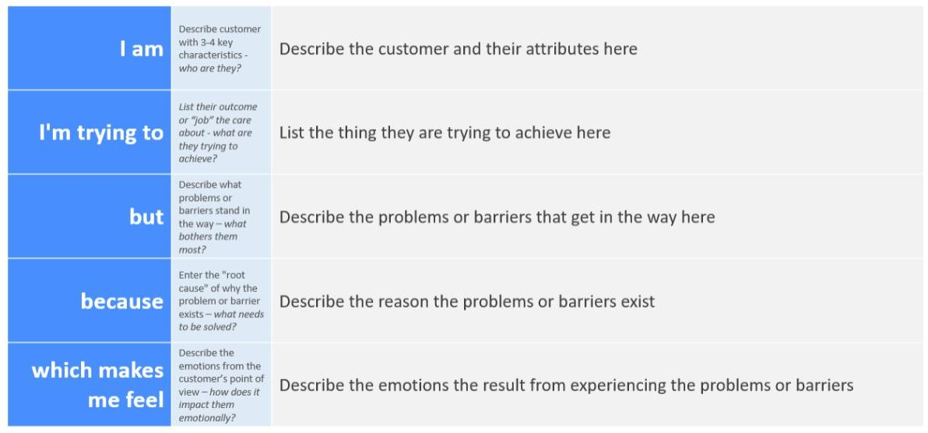

Reference: <https://miro.com/templates/customer-problem-statement/>

**Example:**

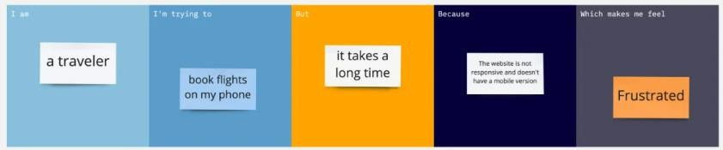

|  |  |  |  |  |  |
| --- | --- | --- | --- | --- | --- |
| **Problem**  **Statement (PS)** | **I am**  **(Customer)** | **I’m trying to** | **But** | **Because** | **Which makes me feel** |
| PS-1 | a frequent traveler | book flights quickly | the site is slow and  confusing | there are too many  steps and no | frustrated and impatient |

|  |  |  |  |  |  |
| --- | --- | --- | --- | --- | --- |
|  |  |  |  | filters for  preferences |  |
| PS-2 | someone booking for family | find affordable group flights | it’s hard to compare prices across  airlines | there’s no side-by-side comparison feature | overwhelmed and stressed |